Name __________________________________
Assignment: WKST: Continents Review Maps_
Subject/Period ___________________________
Date ___________________________________
Identify the following continents:
1. Locate and label the following on the map using p. 412 of your textbook
A _________________________ D _________________________ F _________________________
B ________ _ ____ E Antarctica G _________________________
C _________________________
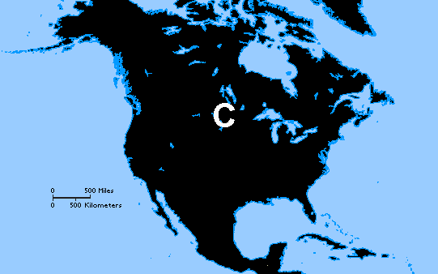
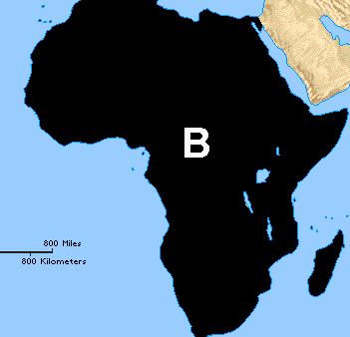
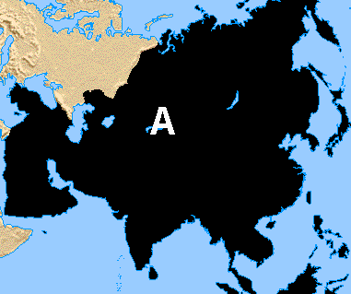

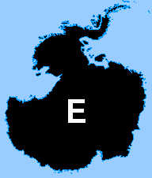
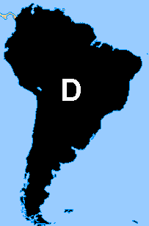
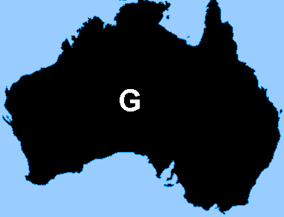
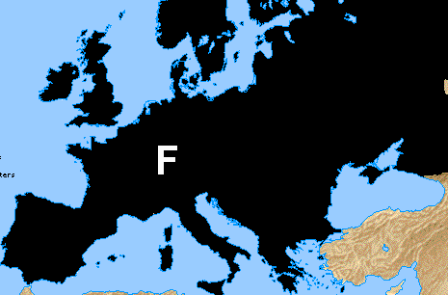

Directions: Looking at the continents shapes from page 1, write the letter of each continent on its corresponding location on the map below.

World Continents
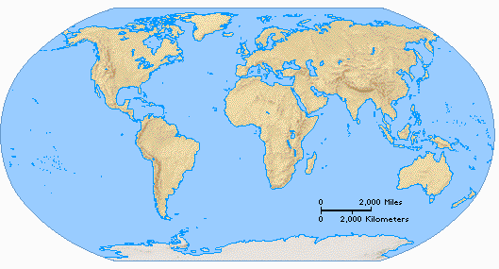

Directions: 1) Label Africa 2) Color in the Fertile Crescent 3) Draw arrows showing human migration & label places where humans
migrated

World Continents
